FUNCTIONAL REQUIREMENTS DOCUMENT
AI-Powered Property Management and Services Platform
Table of Contents
1. Purpose 2
2. Product Scope 2
3. Product Delivery Phases 3
3.1 Phase 1 – Business-to-Business Platform 3
3.2 Phase 2 – Business-to-Consumer Marketplace 3
4. User Roles 4
5. User, Organization, and Role Management 4
6. Property and Unit Management 5
7. Tenant and Lease Management 6
8. Maintenance Management 6
9. AI-Assisted Operations 8
10. Contractor Marketplace 9
11. Gig Worker and Field Service Management 9
12. Job Execution and Verification 10
13. Inspection and Compliance Management 11
14. Rent Collection 11
15. Notice Management 12
16. Legal and Attorney Services 12
17. Payments and Financial Workflows 13
18. Documents and Media Management 13
19. Messaging and Notifications 14
19.1 Messaging 14
19.2 Notifications 14
20. Dispute Management 15
21. Ratings and Performance Management 16
22. Dashboards 16
23. Reporting and Analytics 17
24. Platform Administration 18
25. Core Business Rules 18
26. Security and Privacy Requirements 19
27. Audit and Activity History 19
28. MVP Delivery Scope 20
29. Assumptions and Dependencies 21
30. Functional Acceptance 21
31. Flow Diagram 22

Purpose
This Functional Requirements Document defines the business and functional requirements for an AI-powered property management platform.
The platform will provide a centralized ecosystem for property owners, managers, tenants, contractors, field workers, inspectors, attorneys, and platform administrators to manage property operations, maintenance, inspections, compliance, payments, communications, and related services.
The platform shall support a single mobile application with role-based access and a web-based administration portal.

Product Scope
The platform shall support the following core business areas:
- User and Organization Management
- Role-Based Access Control
- Property and Unit Management
- Tenant and Lease Management
- Maintenance Management
- AI-Assisted Operations
- Contractor Marketplace
- Gig Worker and Field Services
- Job Execution and Verification
- Inspection and Compliance
- Rent Collection
- Notice Management
- Legal and Attorney Services
- Payments and Financial Workflows
- Documents and Media
- Messaging and Notifications
- Dispute Management
- Ratings and Performance
- Dashboards, Reporting, and Analytics
- Platform Administration

Product Delivery Phases

3.1 Phase 1 – Business-to-Business Platform
The initial platform shall primarily support:
- Property owners and landlords
- Property managers
- Tenants
- Contractors
- Field and gig workers
- Inspectors
- Attorneys
- Platform administrators
Phase 1 will focus on professional property management operations and marketplace services.

3.2 Phase 2 – Business-to-Consumer Marketplace
Phase 2 may extend the marketplace to individual homeowners and consumers.
The high-level consumer workflow may include:
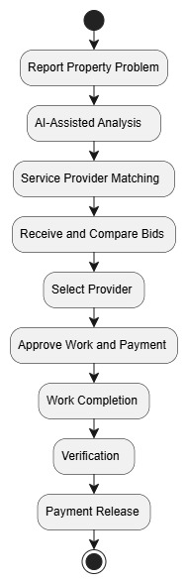
Phase 2 requirements shall be finalized separately before implementation.

User Roles
The platform shall support the following primary roles:
- Tenant
- Landlord / Property Owner
- Property Manager
- Contractor
- Gig Worker / Field Worker
- Inspector
- Attorney
- Platform Administrator
A user may belong to multiple organizations and may have multiple roles within the same organization.
The system shall determine the user's accessible features based on:
- Organization membership
- Assigned role
- Permissions
- Resource assignment
- Active organization
- Active role context

User, Organization, and Role Management
The platform shall support:
- User registration
- Secure authentication
- User profile management
- Organization creation and management
- Multiple organization memberships
- Role assignment
- Permission management
- Organization switching
- Role switching
- Active session management

Role Selection
When a user log in:
- If the user has one eligible role within the selected organization, the role shall be activated automatically.
- If the user has multiple eligible roles, the application shall display available roles.
- The user shall select the role in which they wish to continue.
- The application shall load features and navigation appropriate to the selected role.
- Users may switch roles later, subject to authorization.

Property and Unit Management
Authorized users shall be able to create and manage properties.
Property information may include:
- Property name
- Address
- Property type
- Number of units
- Year built
- Property characteristics
- Jurisdiction
- Ownership information
- Assigned property manager
- Insurance information
The platform shall support unit-level information, including:
- Unit identification
- Tenant association
- Lease information
- Monthly rent
- Security deposit
- Lease expiration
- Payment history
- Notice history
Each property shall be associated with an authorized organization.
The applicable jurisdiction shall be identified or assigned to support compliance and regulatory workflows.

Tenant and Lease Management
Authorized users shall be able to:
- Create and manage tenant profiles
- Associate tenants with properties and units
- Maintain tenancy information
- Maintain lease information
- Track lease start and expiration dates
- Track rent obligations
- View payment history
- View maintenance history
- View notices
- Manage tenant-related documents
Tenants shall only access information related to their authorized property, unit, lease, and permitted activities.

Maintenance Management
Authorized users shall be able to create, manage, track, and resolve maintenance requests.
A maintenance request may include:
- Category
- Description
- Property and unit
- Location
- Priority or emergency indication
- Preferred availability
- Photos
- Videos
- Supporting documents
The system shall provide maintenance history and status tracking.

Maintenance Lifecycle
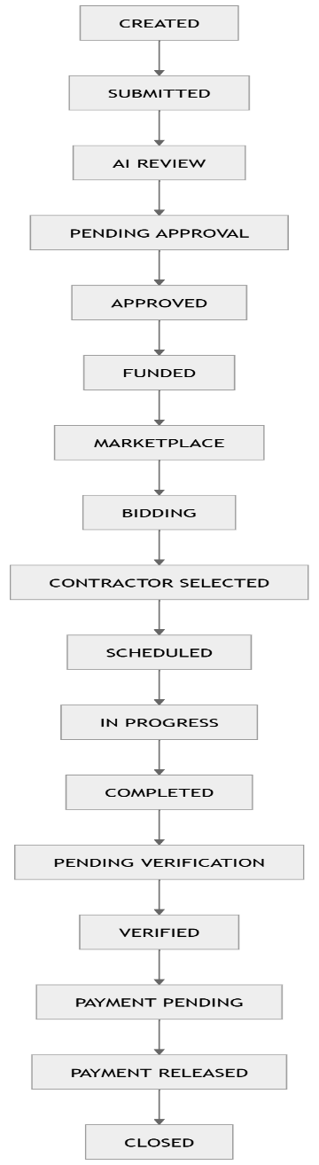
Alternate states may include:
- DISPUTED
- CANCELLED
Workflow transitions shall be controlled according to business rules and authorized user actions.

AI-Assisted Operations
AI shall support business processes by providing recommendations and analysis.
AI capabilities may include:
Maintenance Intelligence
- Issue classification
- Photo analysis
- Urgency assessment
- Trade recommendations
- Maintenance recommendations
Marketplace Intelligence
- Contractor recommendations
- Bid analysis
- Price anomaly detection
Inspection Intelligence
- Inspection preparation
- Report analysis
- Finding identification
- Recommended corrective actions
Compliance Intelligence
- Deadline identification
- Missing document identification
- Compliance recommendations
Property Intelligence
- Activity summaries
- Pattern identification
- Predictive maintenance insights
- Operational alerts
AI output shall be treated as assistance or recommendations. High-impact financial, legal, or regulatory decisions shall require authorized review and approval where applicable.

Contractor Marketplace
The platform shall allow contractors to:
- Create and manage professional profiles
- Define services and trades
- Define service areas
- Manage availability
- Upload licenses and credentials
- Upload insurance information
- View eligible opportunities
- Submit bids
- Manage awarded work
- Track work history
Authorized property representatives shall be able to:
- Publish service opportunities
- Invite eligible contractors
- Review bids
- Compare bids
- Review qualifications
- Select contractors
Contractor matching may consider:
- Service category
- Location
- Availability
- License status
- Insurance status
- Ratings
- Historical performance
- Price
- Response time

Gig Worker and Field Service Management
The platform shall support qualified gig workers and field workers for property-related assignments.
Supported activities may include:
- Property inspections
- Pre-inspections
- Post-work verification
- Inspection attendance
- Notice delivery
- Property photography
- Condition verification
- Key handover
- Other approved field assignments
Workers shall be able to:
- View eligible assignments
- Accept assignments
- View assignment instructions
- Upload evidence
- Update assignment status
- Submit completion details

Job Execution and Verification
The platform shall manage the lifecycle of assigned work.
Supported capabilities shall include:
- Job assignment
- Scheduling
- Worker assignment
- Check-in
- Progress updates
- Media uploads
- Work notes
- Completion submission
- Verification
Verification may be performed by authorized stakeholders according to the configured workflow.
Work completion may require supporting evidence, including:
- Photos
- Videos
- Notes
- Invoices
- Inspection results

Inspection and Compliance Management
The platform shall support inspection planning, execution, tracking, and corrective actions.
Capabilities shall include:
- Inspection scheduling
- Inspection types
- Checklists
- Inspection records
- Findings
- Supporting media
- Corrective actions
- Re-inspection
- Inspection history
The platform shall support applicable compliance requirements based on property jurisdiction and configuration.
Compliance capabilities may include:
- Compliance requirements
- Deadlines
- Recurring obligations
- Certifications
- Licenses
- Supporting documents
- Compliance calendar
- Reminders
- Re-inspection and recertification tracking
The system shall support workflows for failed inspections and corrective actions.

Rent Collection
The platform shall support rent-related financial management, including:
- Rent schedules
- Rent due dates
- Tenant payment tracking
- Outstanding balances
- Payment history
- Payment receipts
- Late payment tracking
- Payment reminders
Access to rent information shall be restricted based on user authorization.

Notice Management
The platform shall support the management of property-related notices.
Capabilities shall include:
- Notice creation
- Notice types
- Notice status
- Jurisdiction-specific requirements
- Notice delivery tracking
- Assignment of delivery tasks
- Proof of service
- Delivery date and time
- Supporting documents
Notice workflows shall be configurable according to applicable jurisdictional requirements.

Legal and Attorney Services
The platform shall support legal services related to property operations.
Attorneys shall be able to:
- Create professional profiles
- Define jurisdictions
- Define legal specialties
- Review eligible legal opportunities
- Provide pricing or proposals
- Manage assigned cases
Authorized property representatives shall be able to:
- Create legal cases
- Share authorized case information
- Review attorney options
- Select attorneys
- Track case progress
Legal case records may include:
- Case details
- Related properties
- Related tenants
- Notices
- Documents
- Activities
- Case status

Payments and Financial Workflows
- The platform shall support payment workflows associated with approved business activities.
- Supported capabilities may include:
  - Payment requests
  - Funding workflows
  - Payment authorization
  - Payment release
  - Contractor payments
  - Platform fees
  - Refunds
  - Disputes
  - Reconciliation
  - Payment history
- The system shall maintain payment transaction records and status history.
- Payment processing shall integrate with approved external payment providers.
- Where required, provider-supported onboarding, identity verification, and regulatory processes shall be used.
- Payment release shall follow configured approval and verification requirements.

Documents and Media Management
Authorized users shall be able to upload, access, and manage:
- Photos
- Videos
- Documents
- Licenses
- Insurance certificates
- Inspection reports
- Invoices
- Legal documents
- Compliance documents
- Other authorized business records
Documents and media shall be associated with relevant business records.

Each record may maintain:
- Document type
- Upload date
- Uploaded by
- Related entity
- Version
- Status
- Expiration date, where applicable
Access shall be controlled according to user authorization.

Messaging and Notifications

19.1 Messaging
The platform shall provide contextual communication between authorized users.
Messages may be associated with:
- Property
- Unit
- Maintenance request
- Job
- Inspection
- Payment
- Legal case
The system shall maintain communication history for authorized audit and operational purposes.

19.2 Notifications
The platform shall support:
- Push notifications
- Email notifications
- SMS notifications
- In-app notifications
Notifications may be generated for significant business events such as:
- New maintenance requests
- Approval requests
- Bid submissions
- Assignment updates
- Schedule changes
- Inspection deadlines
- Compliance reminders
- Payment updates
Users may manage applicable notification preferences.

Dispute Management
The platform shall support dispute management related to business activities.
Disputes may relate to:
- Work completion
- Scope of work
- Invoices
- Payment
- Contractor performance
- Budget
- Inspection findings
The dispute process shall support:
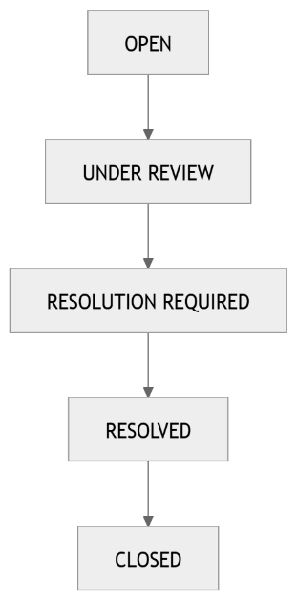
Authorized users shall have access to relevant information required to investigate the dispute, including related activities, communications, documents, media, bids, invoices, and approval history.

Ratings and Performance Management
The platform shall support performance evaluation for completed work.
Authorized users may provide ratings based on:
- Quality
- Timeliness
- Communication
- Professionalism
- Value
The system may maintain performance history to support future service provider selection.

Dashboards
- The platform shall provide role-specific dashboards based on the active organization and role.
- Dashboards shall display relevant information based on user responsibilities.
Tenant
- Maintenance activity
- Rent information
- Appointments
- Notices
- Notifications
Landlord / Property Manager
- Property overview
- Unit status
- Maintenance
- Pending approvals
- Rent status
- Inspections
- Compliance
- Payments
- Upcoming activities
Contractor
- Opportunities
- Bids
- Assigned jobs
- Schedule
- Payment status
- Performance information
Field Worker / Gig Worker
- Assigned tasks
- Schedule
- Instructions
- Completion requirements
Inspector
- Assigned inspections
- Checklists
- Findings
- Corrective actions
- Re-inspections
Attorney
- Assigned cases
- Legal activities
- Documents
- Case deadlines
Dashboard information shall be dynamically controlled according to permissions and active role context.

Reporting and Analytics
Authorized users shall be able to access reports and analytics relevant to their responsibilities.
Reporting areas may include:
- Property performance
- Occupancy
- Rent collection
- Maintenance activity
- Contractor performance
- Job completion
- Inspection results
- Compliance status
- Payment activity
- Marketplace performance
Reports shall respect organization, role, and resource-level access permissions.

Platform Administration
The Administration Portal shall support authorized administrators in managing:
- Users
- Organizations
- Roles
- Permissions
- Properties
- Contractors
- Gig workers
- Inspectors
- Attorneys
- Marketplace configuration
- Compliance configuration
- Payment configuration
- Notification configuration
- Feature configuration
- Disputes
- Audit records
- Platform operations
Administrative access shall be controlled by appropriate permissions.

Core Business Rules
The following rules shall apply across the platform:
- Users shall access only authorized organizations, roles, and resources.
- A user may have multiple roles within an organization.
- Role-specific features shall be determined by the active role context.
- Users with multiple roles shall be able to select an eligible role after login.
- Authorized users may switch roles subject to configured access rules.
- Protected operations shall require authorization.
- Business workflows shall allow only valid state transitions.
- Important business actions shall be recorded for audit purposes.
- Payment release shall follow configured authorization and verification requirements.
- AI shall provide recommendations and assistance rather than uncontrolled autonomous decisions.
- Access to sensitive information shall be restricted according to authorization.
- Jurisdiction-specific requirements shall be applied where relevant.
- Related documents, activities, and communications shall be associated with their corresponding business records.
- Separation of duties may be enforced for sensitive operations, including financial approvals.

Security and Privacy Requirements
The platform shall support appropriate security controls, including:
- Secure authentication
- Role-based authorization
- Multi-factor authentication where required
- Secure session management
- API access controls
- Encryption of sensitive information
- Secure document and media access
- Audit logging
- Data backup
- Recovery procedures
- Privacy controls
Payment-related sensitive information shall be handled through approved payment providers where applicable.

Audit and Activity History
The platform shall maintain an auditable history for significant business activities.
Audit information may include:
- User
- Organization
- Active role
- Action
- Date and time
- Related business record
- Previous and updated values where applicable
Audit records shall be accessible only to authorized users.

MVP Delivery Scope
The recommended initial implementation sequence is:
Priority 1 — Platform Foundation
- Authentication
- Organizations
- Roles and permissions
- Property and unit management
- Tenant management
Priority 2 — Core Operations
- Maintenance
- Media uploads
- Workflow management
- Messaging
- Notifications
Priority 3 — Marketplace
- Contractor onboarding
- Gig worker management
- Opportunities
- Bidding
- Assignment
- Job execution
- Verification
Priority 4 — Intelligence and Compliance
- AI-assisted maintenance
- Inspection management
- Compliance tracking
- Document management
Priority 5 — Financial and Legal Operations
- Payments
- Rent collection
- Notice management
- Dispute management
- Attorney services
Priority 6 — Platform Optimization
- Reporting
- Analytics
- Advanced AI
- Performance optimization
- Security hardening
Final priorities and timelines shall be confirmed with the client before development.

Assumptions and Dependencies
The final implementation will depend on:
- Client approval of functional scope
- Jurisdictional requirements
- Applicable compliance rules
- Payment provider availability
- KYC/KYB requirements
- Third-party service integrations
- AI provider capabilities
- Maps and location provider selection
- Notification service availability
- Legal and regulatory requirements
Any changes to these dependencies may require updates to the functional scope and implementation plan.

Functional Acceptance
The platform shall be considered functionally ready for a release when:
- Approved functional requirements are implemented.
- User roles and permissions operate correctly.
- Critical workflows are validated.
- Required integrations are operational.
- Acceptance criteria are completed.
- Security testing is completed.
- User acceptance testing is approved.

Flow Diagram
